

E-Commerce Web Application

Software Design Specification

Version: 1.0

Date Created: 04/06/2019

Preface

This document presents the Software Design Specification for E-commerce web application Software by Mawai Infotech LTD. The major sections of the document address the system decomposition by module, concurrent process, and data entity. The system dependencies are also described.

Section 2, Decomposition Description, gives a view of the whole system design including concurrent processes and data entities that are common amongst all system modules. This section will also describe the dependency and accessibility of a section from another. This discussion includes a UML Class Diagram that depicts the entire system.

Section 3, Dependency Description covers the view of the dependent modules and how they will function parallel with each other. All the modular dependencies are defined and operational flow is depicted through DFDs of the respective modules.

Section 4, Interface Description, goes into detail about the user interface for each module of the E-commerce web application System. This is followed by an important discussion of the processes implemented in logic for each module of the system.

Section 5, Detailed Design, extends the design discussion found in Section 2 and describes the design for each system module in more detail. Diagrams are included for each module design discussion. This is followed by a description of the data requirements for each module and the design of those data elements.

Table of Contents

1 Introduction 1

1.1 Purpose 1

1.2 Scope 1

1.3 Definitions and Acronyms 1

1.4 References 1

2 Decomposition Description 2

2.1 Module Decomposition 2

2.2 Concurrent Process Decomposition 2

2.3 Data Decomposition 2

3 Dependency Description 3

3.1 Inter-module Dependencies 3

3.1.1 Independent Modules 3

3.1.2 Dependent Modules 3

3.2 Data Dependencies 4

3.2.1 Customer’s modules 4

3.2.2 Vendor’s modules 8

3.2.3 Administrator modules 10

4 Interface Description 15

4.1 Module Interface 15

4.1.1 Registration Module 15

4.1.2 Login Module 16

4.1.3 Navigation bar (Before Login) 16

4.1.4 Navigation Bar (After login) 17

4.1.5 Customer Menus 17

4.1.6 E-commerce web application system login 17

4.1.7 E-commerce web application system login 18

4.1.8 E-commerce web application system login 18

4.1.9 E-commerce web application system login 18

4.1.10 E-commerce web application system login 18

4.1.11 E-commerce web application system login 19

4.1.12 E-commerce web application system login 19

4.1.13 E-commerce web application system login 19

4.1.14 E-commerce web application system login 19

4.1.15 E-commerce web application system login 20

4.1.16 E-commerce web application system login 20

4.1.17 E-commerce web application system login 20

4.1.18 E-commerce web application system login 20

4.1.19 E-commerce web application system login 21

4.1.20 E-commerce web application system login 21

4.1.21 E-commerce web application system login 21

4.1.22 E-commerce web application system login 21

4.1.23 E-commerce web application system login 22

4.1.24 E-commerce web application system login 22

4.1.25 E-commerce web application system login 22

4.1.26 E-commerce web application system login 22

4.1.27 E-commerce web application system login 23

4.1.28 E-commerce web application system login 23

4.1.29 E-commerce web application system login 23

4.1.30 E-commerce web application system login 23

4.1.31 E-commerce web application system login 24

4.1.32 E-commerce web application system login 24

4.1.33 E-commerce web application system login 24

4.1.34 E-commerce web application system login 24

4.1.35 E-commerce web application system login 25

4.1.36 E-commerce web application system login 25

4.1.37 E-commerce web application system login 25

4.1.38 E-commerce web application system login 25

4.1.39 E-commerce web application system login 26

4.1.40 E-commerce web application system login 26

5 Detailed Design 27

5.1 Module Detailed Design 27

5.1.1 Form filling Module 27

5.1.2 Staff quarter system login module 28

5.1.3 Security Module 28

Appendix A – Staff Quarter system Class Diagram 30

Appendix B – Staff Quarter system Use Case Diagram 31

Appendix C – Staff Quarter system Sequence Diagram 31

Appendix D– Staff Quarter system Activity Diagram 33

Appendix E – Staff Quarter system Collaboration Diagram 34

**Table of Figures**

Figure 1: Signup module DFD 4

Figure 2: Login Module DFD 5

Figure 3: View products DFD 5

Figure 4: Place order DFD 6

Figure 5: Update Product Details DFD 6

Figure 6: Purchase items and payment process DFD 7

Figure 7: View Invoice Details DFD 7

Figure 8: Add products DFD 8

Figure 9: Update Product details DFD 8

Figure 10: Delete product DFD 9

Figure 11: View Orders DFD 9

Figure 12: Add category DFD 10

Figure 13: Add subcategories DFD 10

Figure 14: Adding Privileges DFD 11

Figure 15: Update Privileges DFD 11

Figure 16: Remove privileges DFD 12

Figure 17: Adding new user DFD 12

Figure 18: Update user details DFD 13

Figure 19: Remove User DFD 13

Figure 20: Viewing transaction module DFD 14

Figure 21: Signup UI diagram 15

Figure 22: Login UI diagram 16

Figure 23: Navigation Bar (Before Login) UI Diagram 16

Figure 24: Navigation Bar (After Login) UI Diagram 17

Figure 25: Customer Menus UI diagram - (i) 17

Figure 26: Customer Menus UI diagram - (ii) 17

**List of tables**

Table 1: Definitions, Acronyms and abbreviations 1

Table 2: References 1

# Introduction

## Purpose

The purpose of the Software Design Specification is to describe the specific design of the E-commerce web application software by Mawai Infotech LTD. The design specification includes an overview of the design along with software module decomposition.

This document provides a detailed description of each software module’s design. For each module, a user interface design and class diagram design is given. As well, a process description is described for each module. It is in the process description that the details of what logic will need to be implemented are given.

## Scope

It is within the scope of the Software Design Specification to describe the specific system design of the E-commerce web application project. This would include user interface design, object-oriented class design, process design, and data design. Any specific detail that is needed about the standards or technology used to design the software are within the scope of this document.

It is outside the scope of this document to describe the need of E-commerce web application software and also its advantages and need for a particular part of work. It is also outside the scope of this document to describe in any detail at all how certain mentioned standards or technologies work and operate.

## Definitions and Acronyms

Table 1: Definitions, Acronyms and abbreviations

|  |  |
| --- | --- |
| **Definition, Acronym, or Abbreviation** | **Description** |
| SDS | Software Design Specification. |
| DB | Database |
| SQL | Structured Query Language |

## References

Table 2: References

|  |  |
| --- | --- |
| **References** | **Description** |
| Project planning Document | The project planning document of E-commerce web application System which has been made first was referenced. |
| Software Requirements Specification | The Software Requirements Specification from the E-commerce web application project was referenced. |

# Decomposition Description

## Module Decomposition

The E-commerce web application software is decomposed into following modules:

* Login/Signup module
* Buying products
* Viewing products in cart
* Modifying products in cart
* Payment process
* E-mail and message confirmation
* Viewing and print order receipts
* Adding products to database
* Modifying products details
* Deleting products from database
* Viewing and printing orders information
* Adding categories and subcategories
* Adding users to database
* Editing user details.
* Removing users from database.
* Adding privileges of the user.
* View and print transaction details.

## Concurrent Process Decomposition

The E-commerce web application software consists of following concurrent processes –

* **Buying products and generation of order receipt –** These processes will be initiated when a customer will buy products. After the customer has finalized the products he wants to purchase, then he will proceed to pay and after that, automatically, the order receipt will be generated. The summary of the order will also be sent through a message on the phone number provided by him.
* **Adding products in bulk and displaying incomplete entries –** These processes are concurrent as first, if the vendor add products in bulk, he/she cannot upload the images of the products, so the form of completing the incomplete entries will be opened and all the products which are added via the excel sheet are displayed. Then, vendor upload the images of the products, and then the images will be displayed at the customer side while buying the items.

## Data Decomposition

Following are the major data components –

* **Login Information –** This data component will be stored in order to allow the users to access the application and perform the necessary task. This information is private and will be kept secured. This information will be entered by the user at time of logging in to the application for product purchase, and by vendor at the time of product management.
* **Products Information –** This data component will be stored in order to allow customers to view items. The customer will log in to the application and when he will select the category, then, the products details will be displayed to him.
* **Order information –** This data component will be used in order to store the details of the products, that user has bought. This information will be used by the vendor to deliver the products to the customer. The order details will contain all the information of the product along with the quantity ordered by the customer.
* **Transaction Details –** This data component is stored to allow the administrator to view all transaction on the application. In case, there is a problem between customer and vendor regarding transaction, administrator can look up to the details and proceed with action.

# Dependency Description

## Inter-module Dependencies

### Independent Modules

The following modules are independent and do not rely on any other modules to initiate them or to provide data.

* Login/Signup module
* Viewing products in cart
* Buying products
* Modifying products in cart
* Viewing and print order receipts
* Adding products to database
* Modifying products details
* Deleting products from database
* Viewing and printing orders information
* Adding categories and subcategories
* Adding users to database
* Editing user details.
* Removing users from database.
* Adding privileges of the user.

### Dependent Modules

The following modules are dependent on one another for their functioning.

* Payment process – This module is dependent on buying products module, as payment process is initiated once the user has confirmed the order. After order confirmation only, the payment process should be done, so, the amount to be paid is received from the buying products module and then forwarded to the payment gateway service for process.
* Email and message confirmation – This module is dependent on payment process module. After successful payment only, the user should receive mail and message stating that the order has been confirmed. As, the message will contain information about the products ordered and bill amount, so it has to be processed after successful order placement.
* Viewing and printing transaction details – This is a module of administrator, but it is dependent on the customer module of purchasing item because, the transaction receipt is generated once the payment on the customer side is successful. After that, the transaction details are sent to customer’s mail id and mobile number. The same transaction receipt can be viewed on the administrator side after that. So, this module is dependent on purchasing item and payment process module.

## Data Dependencies

The following Data Flow Diagrams shows the data dependencies between various components of the system and database. Each module has its own data dependencies which are represented module-wise below –

### Customer’s modules

1. Sign up module

Figure 1: Signup module DFD

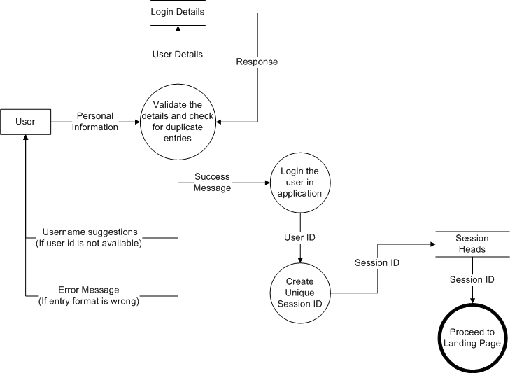

1. Login module

Figure 2: Login Module DFD

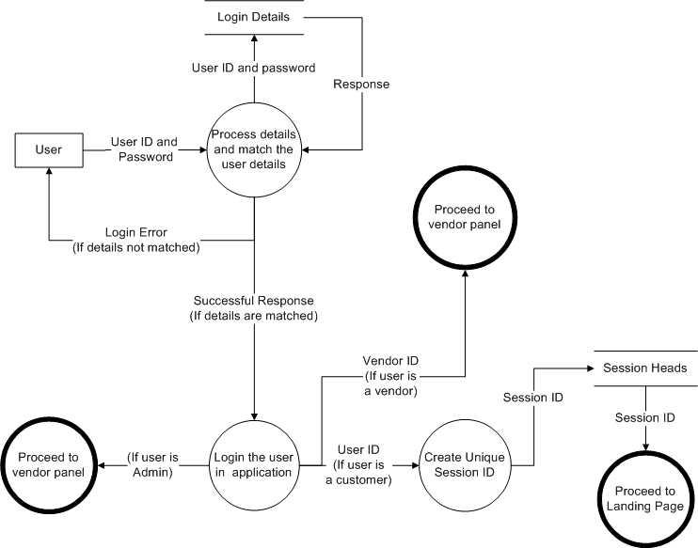

1. View products module

Figure 3: View products DFD

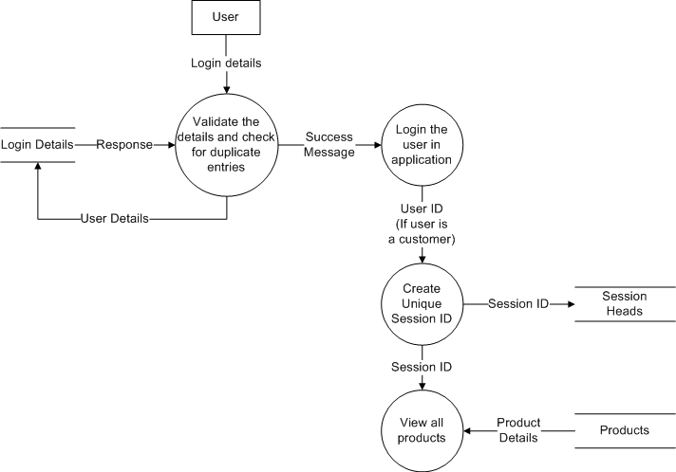

1. Place order module

Figure 4: Place order DFD

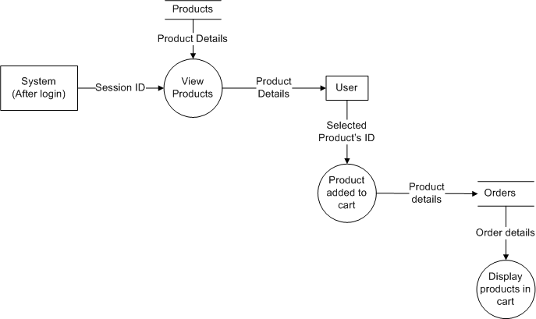

1. Modify order module

Figure 5: Update Product Details DFD

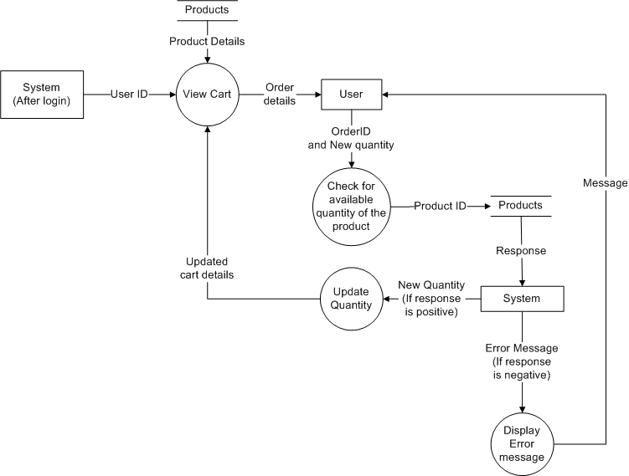

1. Purchasing items and payment process

Figure 6: Purchase items and payment process DFD

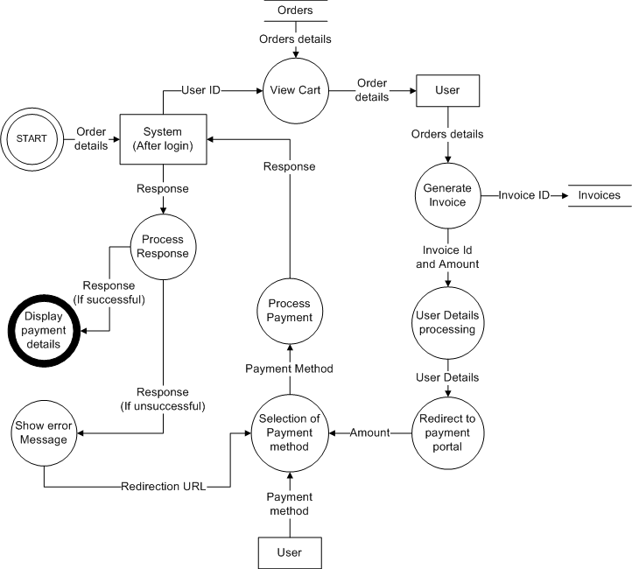

1. Viewing order receipts

Figure 7: View Invoice Details DFD

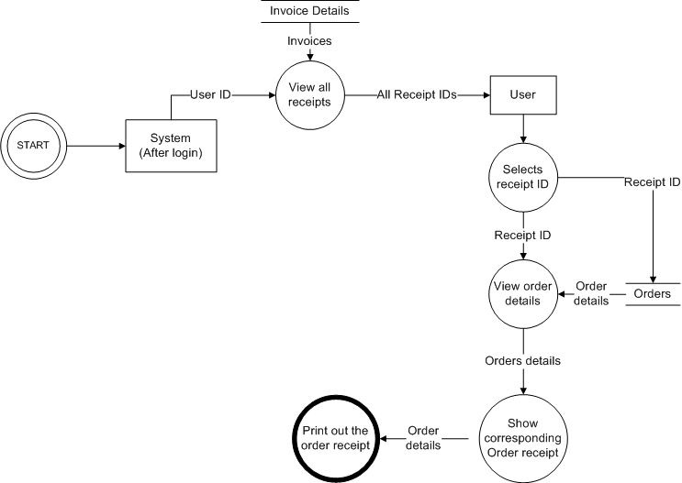

### Vendor’s modules

1. Adding products module

Figure 8: Add products DFD

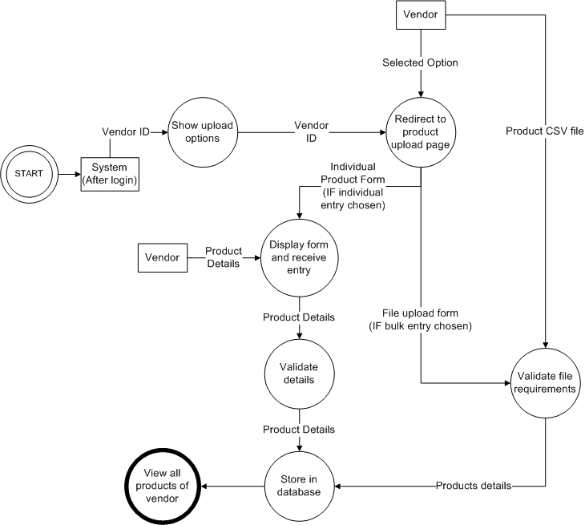

1. Update Product details module

Figure 9: Update Product details DFD

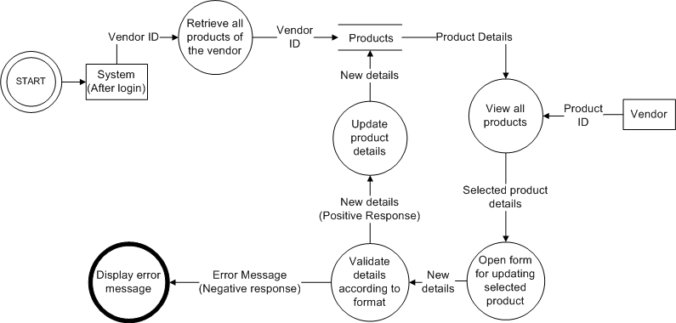

1. Deleting product module

Figure 10: Delete product DFD

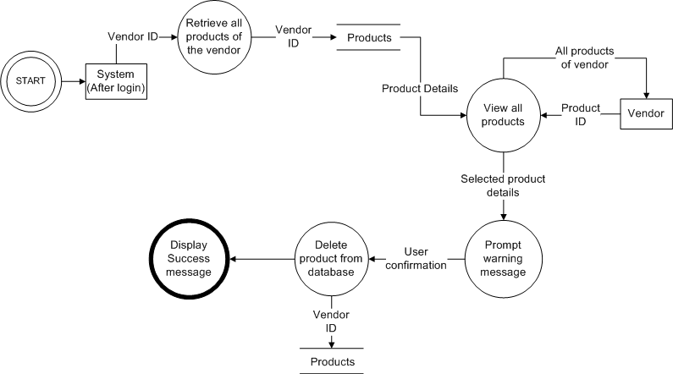

1. Viewing Orders module

Figure 11: View Orders DFD

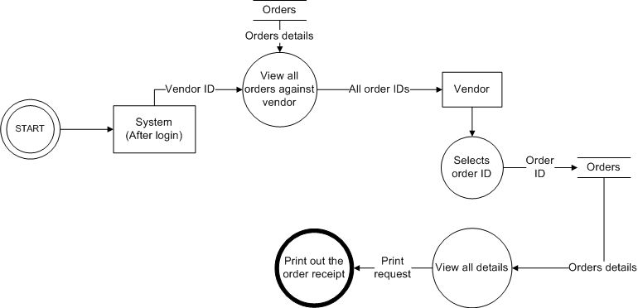

### Administrator modules

1. Adding categories module

Figure 12: Add category DFD

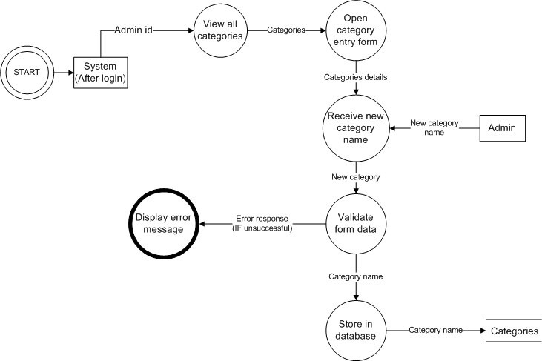

1. Adding subcategories module

Figure 13: Add subcategories DFD

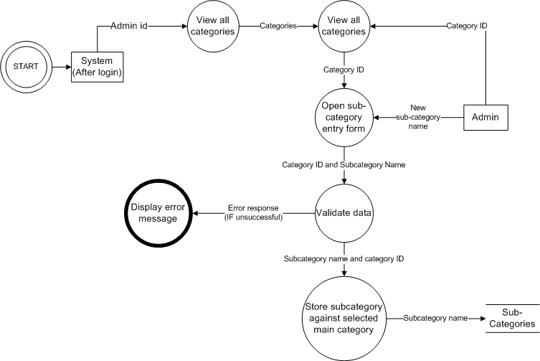

1. Adding privileges module

Figure 14: Adding Privileges DFD

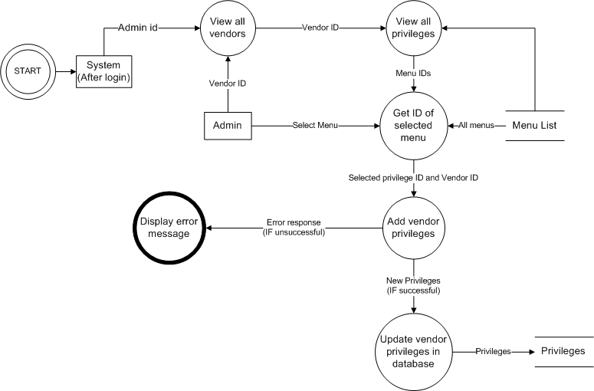

1. Updating privileges module

Figure 15: Update Privileges DFD

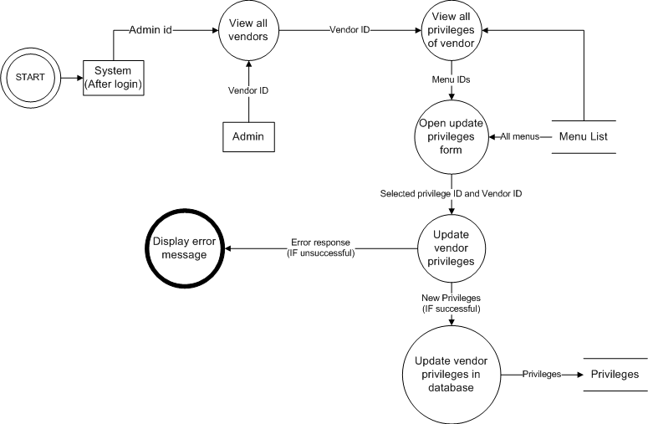

1. Deleting privileges module

Figure 16: Remove privileges DFD

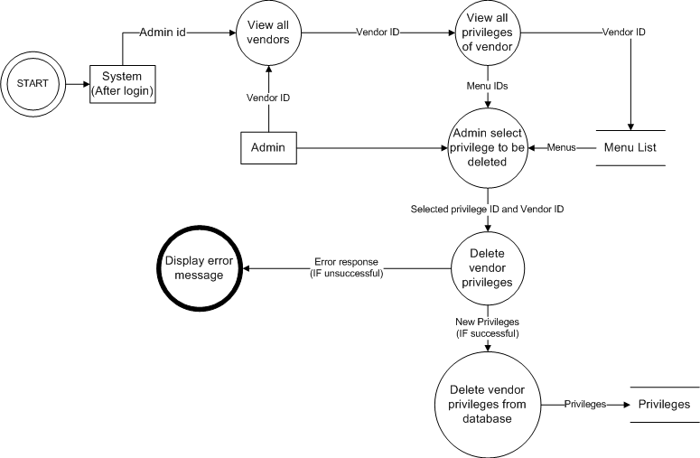

1. Adding new user module

Figure 17: Adding new user DFD

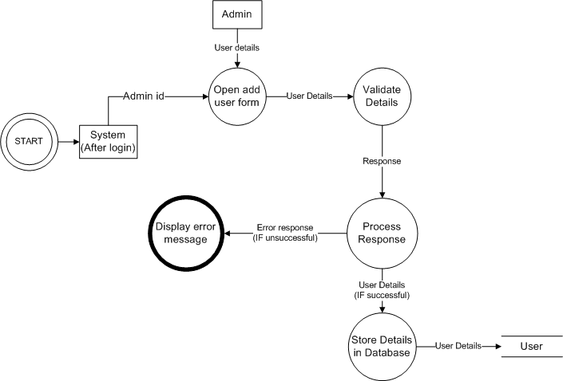

1. Updating user details module

Figure 18: Update user details DFD

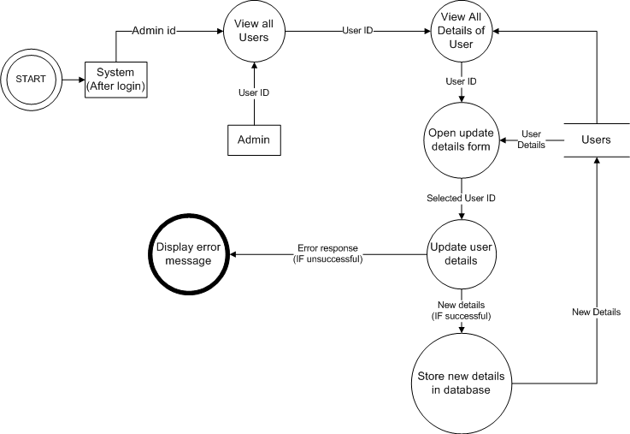

1. Removing user module

Figure 19: Remove User DFD

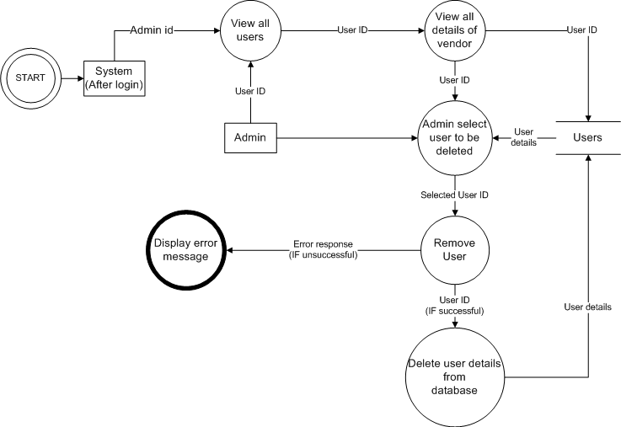

1. Viewing transaction module

Figure 20: Viewing transaction module DFD

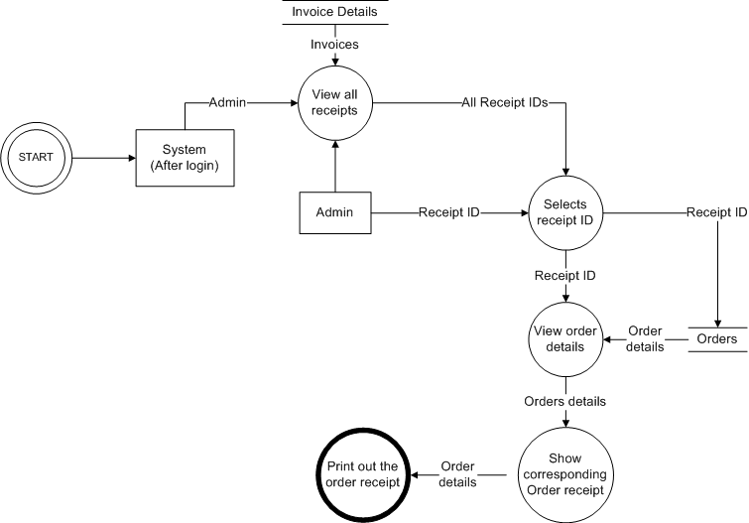

# Interface Description

## Module Interface

### Registration Module

#### User Interface Design

Figure 21: Signup UI diagram

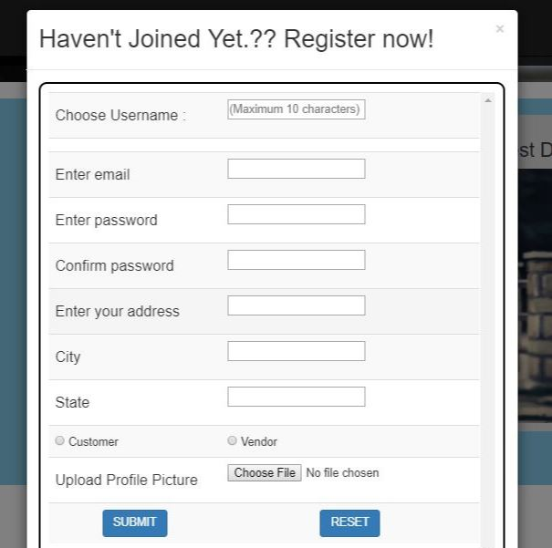

#### Description

This above UI form shows the signup page, which, the user has to fill for registering in the application. After registration, user will have the access to the features of the application such as viewing products, adding products to cart, etc. But the condition will be that, the username should be unique, otherwise there are chances of failure login and database error. After successfully meeting all the requirements, the user can login into the system using the same username and password.

### Login Module

#### User Interface Design

Figure 22: Login UI diagram

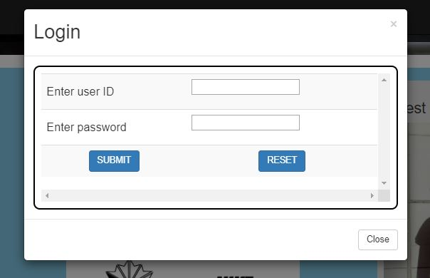

#### Description

This User Interface shows, how the user has to login into the system using his username and password. The username and password was set by the user before. After logging in to the system, the user will be able to perform the desired operations, which he wants to. The user details will be matched here in the backend, an after validation, the user will be redirected to the page. Otherwise, the error will be shown and user has to try again until he enters the right combination of username and password.

### Navigation bar (Before Login)

#### User Interface Design

Figure 23: Navigation Bar (Before Login) UI Diagram



#### Description

This User Interface shows, the navigation bar, which will appear on the top of the page and will contain all the menus available for the user. This is the navigation bar before login. In this, only signup and logion button will be displayed and other menus will be displayed once the user has signed up or logged in.

### Navigation Bar (After login)

#### User Interface Design

Figure 24: Navigation Bar (After Login) UI Diagram



#### Description

This is the navigation bar after login. In this, all the functions of the customer will be displayed and he can move to any of the modules by clicking the respective button.

### Customer Menus

#### User Interface Design

Figure 25: Customer Menus UI diagram - (i)



Figure 26: Customer Menus UI diagram - (ii)



#### Description

There will be categories menu, in which user will get a dropdown, in which he/she can select the main category of the product, he/she wants to purchase. There will be another functions available for the customer. The functions will be – Invoice details (To view the order receipts), Go to cart (To view the items added to cart), Previous Orders (To view the items ordered previously), Logout (To Sign out of the application and go to landing page).

### Landing Pages

#### User Interface Design

#### Description

This User Interface shows, how the user has to login into the system using his username and password. The username and password was set by the user before. After logging in to the system, the user will be able to perform the desired operations, which he wants to.

### E-commerce web application system login

#### User Interface Design

#### Description

This User Interface shows, how the user has to login into the system using his username and password. The username and password was set by the user before. After logging in to the system, the user will be able to perform the desired operations, which he wants to.

### E-commerce web application system login

#### User Interface Design

#### Description

This User Interface shows, how the user has to login into the system using his username and password. The username and password was set by the user before. After logging in to the system, the user will be able to perform the desired operations, which he wants to.

### E-commerce web application system login

#### User Interface Design

#### Description

This User Interface shows, how the user has to login into the system using his username and password. The username and password was set by the user before. After logging in to the system, the user will be able to perform the desired operations, which he wants to.

### E-commerce web application system login

#### User Interface Design

#### Description

This User Interface shows, how the user has to login into the system using his username and password. The username and password was set by the user before. After logging in to the system, the user will be able to perform the desired operations, which he wants to.

### E-commerce web application system login

#### User Interface Design

#### Description

This User Interface shows, how the user has to login into the system using his username and password. The username and password was set by the user before. After logging in to the system, the user will be able to perform the desired operations, which he wants to.

### E-commerce web application system login

#### User Interface Design

#### Description

This User Interface shows, how the user has to login into the system using his username and password. The username and password was set by the user before. After logging in to the system, the user will be able to perform the desired operations, which he wants to.

### E-commerce web application system login

#### User Interface Design

#### Description

This User Interface shows, how the user has to login into the system using his username and password. The username and password was set by the user before. After logging in to the system, the user will be able to perform the desired operations, which he wants to.

### E-commerce web application system login

#### User Interface Design

#### Description

This User Interface shows, how the user has to login into the system using his username and password. The username and password was set by the user before. After logging in to the system, the user will be able to perform the desired operations, which he wants to.

### E-commerce web application system login

#### User Interface Design

#### Description

This User Interface shows, how the user has to login into the system using his username and password. The username and password was set by the user before. After logging in to the system, the user will be able to perform the desired operations, which he wants to.

### E-commerce web application system login

#### User Interface Design

#### Description

This User Interface shows, how the user has to login into the system using his username and password. The username and password was set by the user before. After logging in to the system, the user will be able to perform the desired operations, which he wants to.

### E-commerce web application system login

#### User Interface Design

#### Description

This User Interface shows, how the user has to login into the system using his username and password. The username and password was set by the user before. After logging in to the system, the user will be able to perform the desired operations, which he wants to.

### E-commerce web application system login

#### User Interface Design

#### Description

This User Interface shows, how the user has to login into the system using his username and password. The username and password was set by the user before. After logging in to the system, the user will be able to perform the desired operations, which he wants to.

### E-commerce web application system login

#### User Interface Design

#### Description

This User Interface shows, how the user has to login into the system using his username and password. The username and password was set by the user before. After logging in to the system, the user will be able to perform the desired operations, which he wants to.

### E-commerce web application system login

#### User Interface Design

#### Description

This User Interface shows, how the user has to login into the system using his username and password. The username and password was set by the user before. After logging in to the system, the user will be able to perform the desired operations, which he wants to.

### E-commerce web application system login

#### User Interface Design

#### Description

This User Interface shows, how the user has to login into the system using his username and password. The username and password was set by the user before. After logging in to the system, the user will be able to perform the desired operations, which he wants to.

### E-commerce web application system login

#### User Interface Design

#### Description

This User Interface shows, how the user has to login into the system using his username and password. The username and password was set by the user before. After logging in to the system, the user will be able to perform the desired operations, which he wants to.

### E-commerce web application system login

#### User Interface Design

#### Description

This User Interface shows, how the user has to login into the system using his username and password. The username and password was set by the user before. After logging in to the system, the user will be able to perform the desired operations, which he wants to.

### E-commerce web application system login

#### User Interface Design

#### Description

This User Interface shows, how the user has to login into the system using his username and password. The username and password was set by the user before. After logging in to the system, the user will be able to perform the desired operations, which he wants to.

### E-commerce web application system login

#### User Interface Design

#### Description

This User Interface shows, how the user has to login into the system using his username and password. The username and password was set by the user before. After logging in to the system, the user will be able to perform the desired operations, which he wants to.

### E-commerce web application system login

#### User Interface Design

#### Description

This User Interface shows, how the user has to login into the system using his username and password. The username and password was set by the user before. After logging in to the system, the user will be able to perform the desired operations, which he wants to.

### E-commerce web application system login

#### User Interface Design

#### Description

This User Interface shows, how the user has to login into the system using his username and password. The username and password was set by the user before. After logging in to the system, the user will be able to perform the desired operations, which he wants to.

### E-commerce web application system login

#### User Interface Design

#### Description

This User Interface shows, how the user has to login into the system using his username and password. The username and password was set by the user before. After logging in to the system, the user will be able to perform the desired operations, which he wants to.

### E-commerce web application system login

#### User Interface Design

#### Description

This User Interface shows, how the user has to login into the system using his username and password. The username and password was set by the user before. After logging in to the system, the user will be able to perform the desired operations, which he wants to.

### E-commerce web application system login

#### User Interface Design

#### Description

This User Interface shows, how the user has to login into the system using his username and password. The username and password was set by the user before. After logging in to the system, the user will be able to perform the desired operations, which he wants to.

### E-commerce web application system login

#### User Interface Design

#### Description

This User Interface shows, how the user has to login into the system using his username and password. The username and password was set by the user before. After logging in to the system, the user will be able to perform the desired operations, which he wants to.

### E-commerce web application system login

#### User Interface Design

#### Description

This User Interface shows, how the user has to login into the system using his username and password. The username and password was set by the user before. After logging in to the system, the user will be able to perform the desired operations, which he wants to.

### E-commerce web application system login

#### User Interface Design

#### Description

This User Interface shows, how the user has to login into the system using his username and password. The username and password was set by the user before. After logging in to the system, the user will be able to perform the desired operations, which he wants to.

### E-commerce web application system login

#### User Interface Design

#### Description

This User Interface shows, how the user has to login into the system using his username and password. The username and password was set by the user before. After logging in to the system, the user will be able to perform the desired operations, which he wants to.

### E-commerce web application system login

#### User Interface Design

#### Description

This User Interface shows, how the user has to login into the system using his username and password. The username and password was set by the user before. After logging in to the system, the user will be able to perform the desired operations, which he wants to.

### E-commerce web application system login

#### User Interface Design

#### Description

This User Interface shows, how the user has to login into the system using his username and password. The username and password was set by the user before. After logging in to the system, the user will be able to perform the desired operations, which he wants to.

### E-commerce web application system login

#### User Interface Design

#### Description

This User Interface shows, how the user has to login into the system using his username and password. The username and password was set by the user before. After logging in to the system, the user will be able to perform the desired operations, which he wants to.

### E-commerce web application system login

#### User Interface Design

#### Description

This User Interface shows, how the user has to login into the system using his username and password. The username and password was set by the user before. After logging in to the system, the user will be able to perform the desired operations, which he wants to.

### E-commerce web application system login

#### User Interface Design

#### Description

This User Interface shows, how the user has to login into the system using his username and password. The username and password was set by the user before. After logging in to the system, the user will be able to perform the desired operations, which he wants to.

### E-commerce web application system login

#### User Interface Design

#### Description

This User Interface shows, how the user has to login into the system using his username and password. The username and password was set by the user before. After logging in to the system, the user will be able to perform the desired operations, which he wants to.

# Detailed Design

## Module Detailed Design

### Form filling Module

#### Design

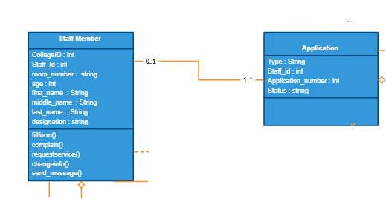

#### Design Description

The E-commerce web application system allows the user to fill the form he wants to which are vacating the room, leave form, apply for mess, cab service, etc. So, this module allows him to choose within the variety of application forms and fill them. After filling it, he can submit the form to the authorities.

### Staff quarter system login module

#### Design

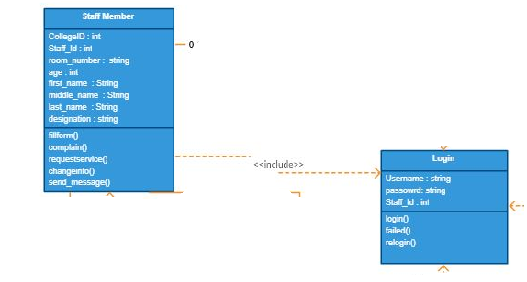

#### Design Description

This module allows the registered staff member to login into the system and then accessing the system functionalities. After that, he can do the things which are meant foe him, like send messages, filling forms, etc. Before logging in to the system, he has to set the username and password for his login system as mentioned above in UI description.

### Security Module

#### Design

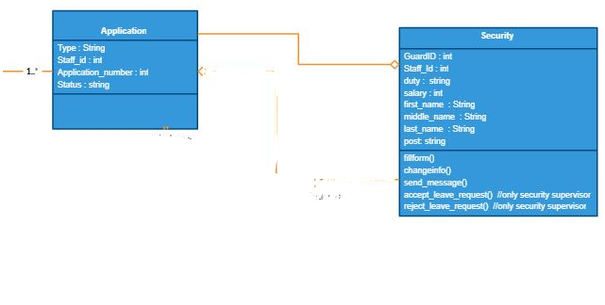

#### Design Description

The security module of E-commerce web application system allows the security supervisor to check for the guards’ application and also, on the other hand allows him to accept or reject the leave application. This module also allows the guards to apply for the leave. And then, the guards are able to see the status of their leave.

# Appendix A – Staff Quarter system Class Diagram

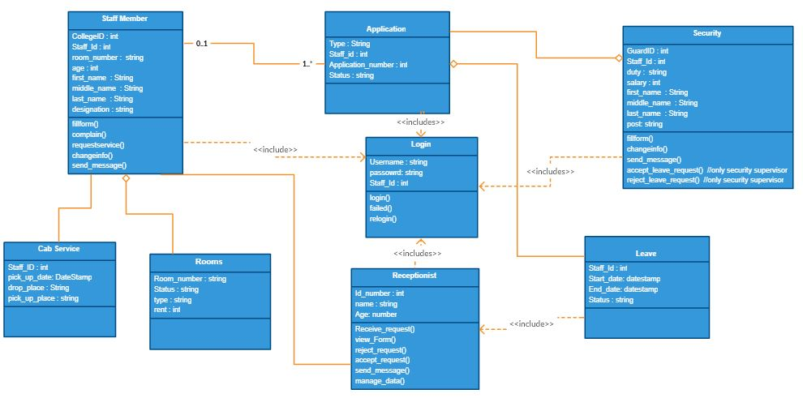

# Appendix B – Staff Quarter system Use Case Diagram

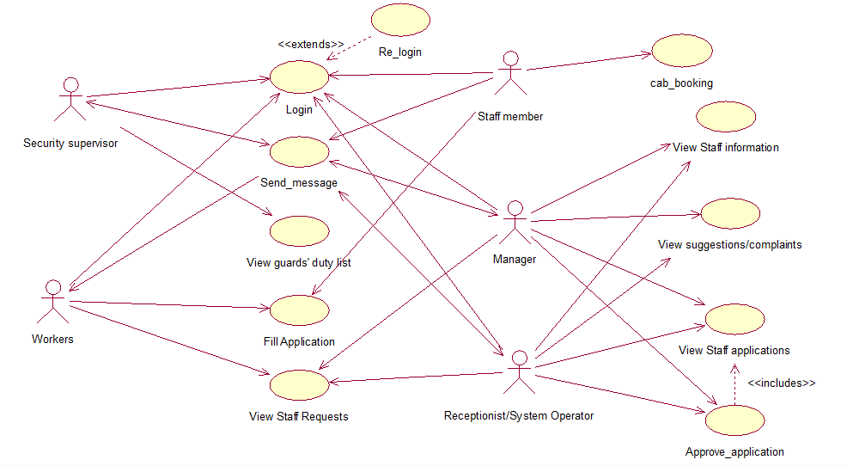

# Appendix C – Staff Quarter system Sequence Diagram

1. **Form-filling**

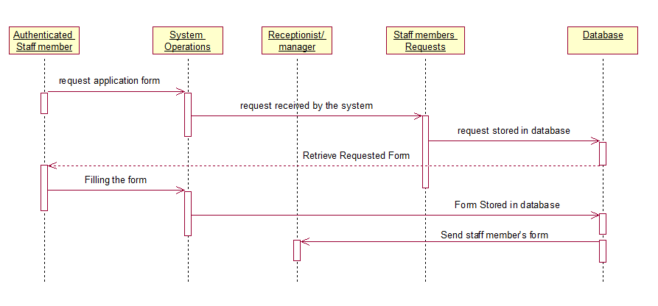

1. **Login system**

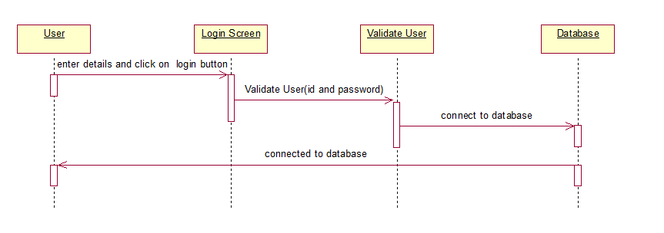

1. **Message Sending**

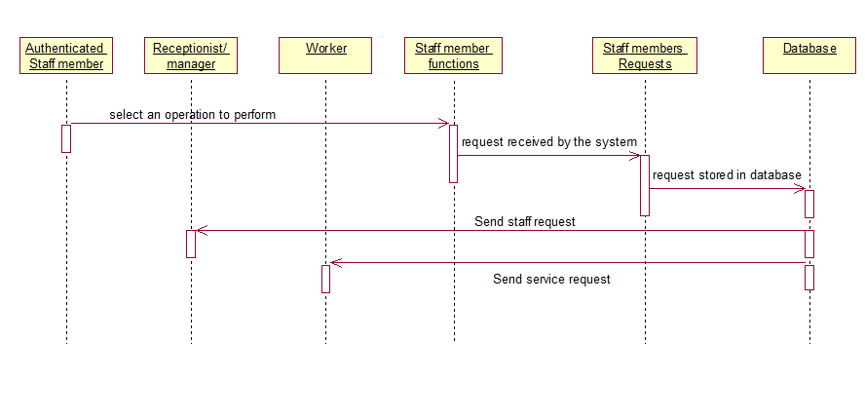

1. **Security**

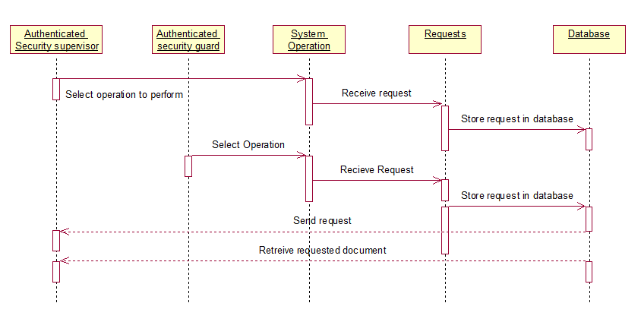

# Appendix D– Staff Quarter system Activity Diagram

1. **Staff Member Module**

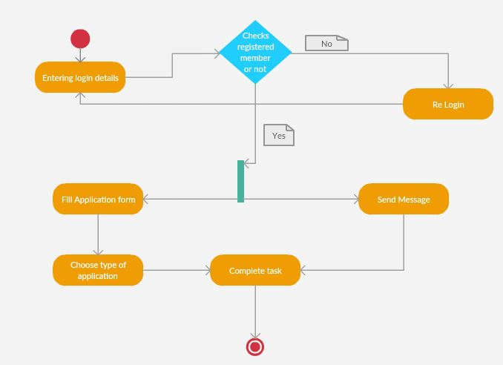

1. **Receptionist Module**

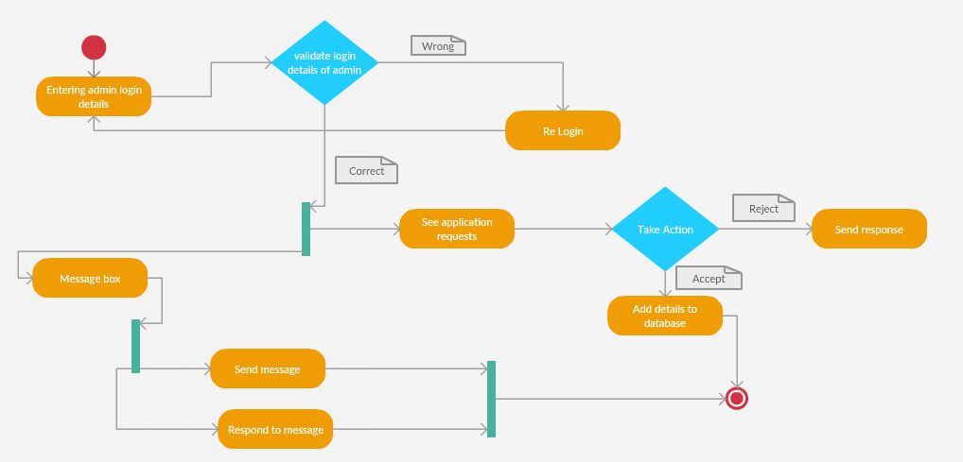

# Appendix E – Staff Quarter system Collaboration Diagram

1. **Form-filling**

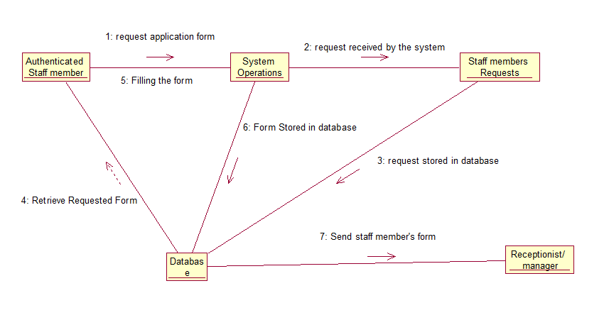

1. **Login system**

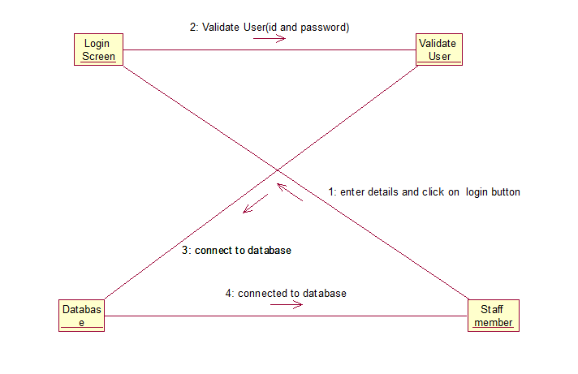

1. **Message Sending**

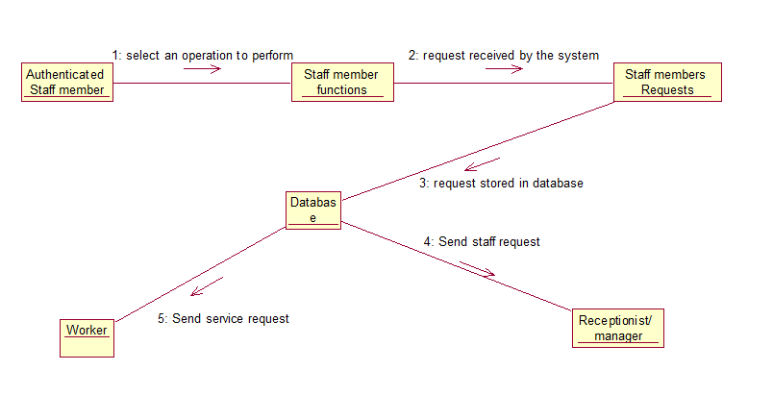

1. **Security**

